**EVENT MANAGEMENT**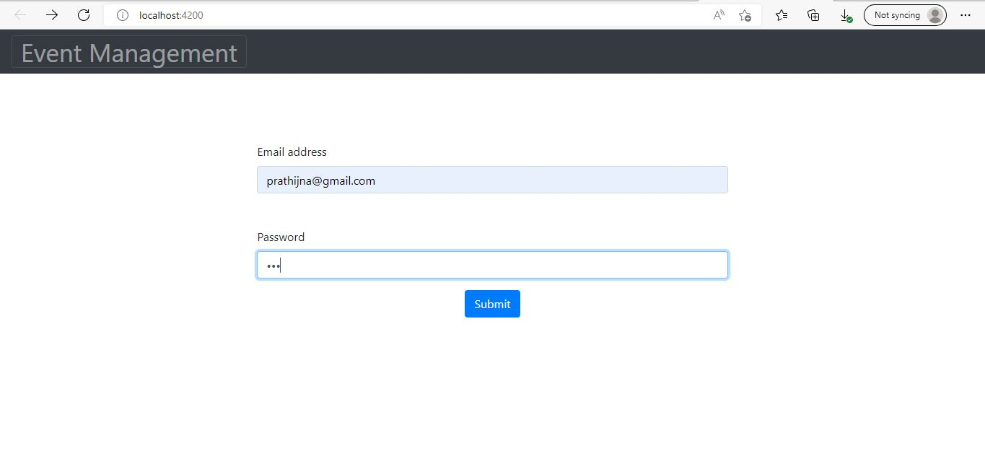

* This is the admin login page where static email id and password is entered

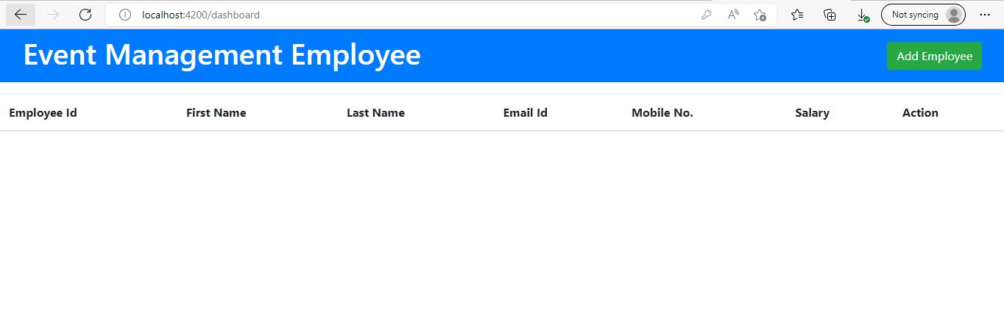

* This is the dashboard of admin
* Admin maintains the adding ad deleting of employees and their details

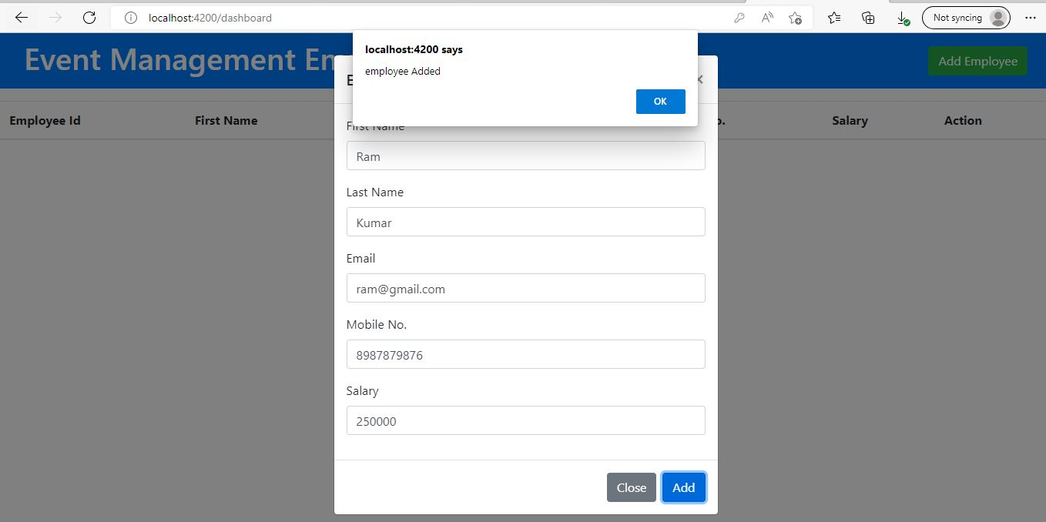

* Admin clicks on add Employees.
* Employee details are entered
* Details like first name, last name, email id, mobile number, and salary details are entered.
* When admin clicks on add button
* Then localhost prompts employee added message will be displayed.

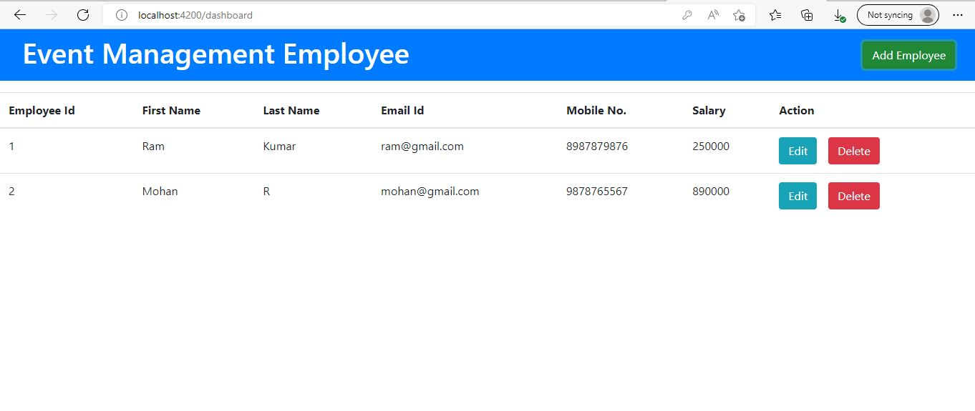

* List of added employee details are visible.
* Admin can edit or delete the employee details